1. Purpose of Data Analysis
The purpose of analyzing this dataset is to understand customer shopping patterns and behavior.
Key goals:
- Identify what factors (age, gender, discount, subscription, etc.) influence purchase amount.
- Segment customers based on frequency, previous purchases, and product categories.
- Predict customer behavior, e.g., likelihood of making a high-value purchase.
- Support marketing decisions like promotions, personalized recommendations, and loyalty programs.
2. Type of Programming Used
Identification: The dataset of shopping behavior is analyzed using Python programming.
Justification:
- Data Handling: Python has pandas to read and organize the CSV data easily into tables (DataFrames).
- Math & Statistics: It has numpy(for numerical calculations), and scipy(Scientific Python) for calculations, averages, probabilities, etc.
- Visualization: With matplotlib and seaborn, we can make graphs to see shopping patterns (like purchase frequency, gender, age groups).
- Machine Learning: Python has scikit-learn for predicting customer behavior and trends.
- Easy & Popular: It is simple to learn, widely used in real-world Data Science projects, and supported everywhere (including Jupiter Notebook).

3. Type & Purpose of Machine Learning Algorithm
For this dataset, a suitable machine learning algorithm is:
- Regression (e.g., Linear Regression, Decision Tree Regressor) if the goal is to predict purchase amount.
- Classification (e.g., Logistic Regression, Random Forest, KNN) if the goal is to
predict customer behavior, such as:
- Will the customer use a promo code?
- Will the customer purchase frequently (Weekly vs. Annually)?
Example choice: Classification with Random Forest to predict whether a customer is a frequent buyer based on age, gender, subscription status, discounts, etc.
Purpose: Helps businesses target frequent customers with offers and convert occasional buyers into loyal ones.

4. Independent & Dependent Variables
Dependent Variable (Target): Could be “Purchase Amount (USD)” (if regression task). Or “Frequency of Purchases” (if classification task).
Independent Variables (Features):
- Demographics: Age, Gender, Location
- Shopping behavior: Previous Purchases, Subscription Status, Discount Applied, Promo Code Used
- Product details: Category, Size, Season, Review Rating
- Transaction details: Payment Method, Shipping Type

5. Sampling: Type & Justification
Type of Sampling Used: Stratified Random Sampling
- We divided the dataset into strata (subgroups) based on Gender and Frequency of Purchases.
- Then, we randomly selected samples proportionally from each subgroup.
- This gave us 30 rows (a smaller dataset) that still preserve the original ratios of Male/Female and Weekly/Monthly/Annual buyers.

Why Stratified Sampling is Best for This Dataset
- Customer Diversity:
  - The dataset contains different customer groups (Male/Female, frequent/occasional shoppers).
  - Stratified sampling ensures all groups are fairly represented in the sample.
- Prevents Bias:
  - If we used simple random sampling, we might accidentally get mostly male weekly buyers and miss annual female buyers.
  - Stratified sampling keeps the same proportions as the full dataset.
- Improves Accuracy:
  - Since shopping behavior depends strongly on frequency of purchases, gender, and age, stratified sampling ensures that predictions or insights from the sample are reliable and generalizable to the whole dataset.
Example of the shopping behavior dataset:
Full dataset: 68% Male, 32% Female; customers purchase Weekly, Monthly, Quarterly, Annually, etc. 30-row sample: Maintains the same Male/Female ratio and ensures all purchase frequencies are represented. This way, the smaller sample reflects the true distribution of the original 3,900 records.

Final Justification:
For customer behavior analysis, Stratified Random Sampling is the most suitable method because it balances representation across groups and reduces sampling error. This ensures that business insights (like which group spends more, who uses discounts, etc.) are accurate and unbiased.

Task 2

1. Justify why you want to perform the descriptive analysis for the chosen 1 dataset.
Descriptive analysis is done to understand the dataset in a clear and simple way. It helps to see how the data is distributed, what the averages and ranges are, and if there are any missing or unusual values. By doing this, we can check the quality of the data and make sure it is accurate before doing deeper analysis. It also helps to discover basic trends and patterns in customer behavior, which can guide the next steps such as feature selection and model building.

2. Create a script to develop a Python function for descriptive statistics. The input for the function should be the sample and the field to perform the descriptive statistics.
import pandas as pd
import numpy as np

ds = pd.read_csv('shopping_behavior_NEW.csv')

# Descriptive stat for all columns
ds.describe().T
Output:

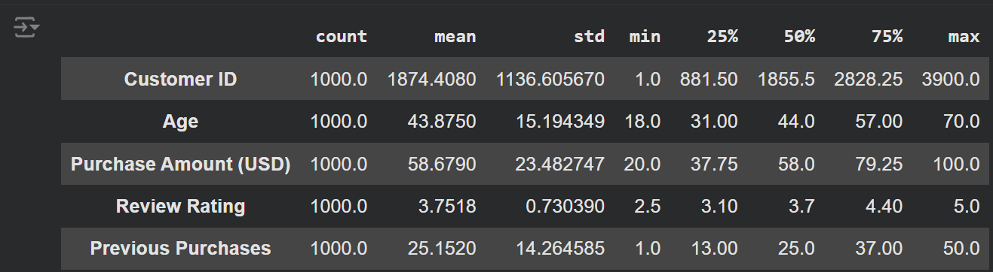
# create a function to find the descriptive stat for the given field
from matplotlib.colors import Normalize
def Desc_stat(ds,var):
mean=ds[var].mean()
median=ds[var].median()
mode=ds[var].mode()
minimum=ds[var].min()
maximum=ds[var].max()
range=ds[var].max() - ds[var].min()
std_dev=ds[var].std()
variance=ds[var].var()
skew=ds[var].skew()
kurtosis=ds[var].kurt()
count=ds[var].count()
Quart = [
ds[var].quantile(0),
ds[var].quantile(0.25),
ds[var].quantile(0.50),
ds[var].quantile(0.75),
ds[var].quantile(1),
ds[var].quantile(0.75) - ds[var].quantile(0.25)
]

summary = {
"Average ": mean,
"Median ": median,
"Mode ": mode,
"Minimum ": minimum,
"Maximum " : maximum,
"Range ": range,
"Std Dev ": std_dev,
"Variance ": variance,
"Skewness ": skew,
"Kurtosis ": kurtosis,
"Minimum ": Quart[0],
"25th Pecentile ": Quart[1],
"50th Pecentile ": Quart[2],
"75th Pecentile ": Quart[3],
"Maximum ": Quart[4],
"Inter Quartile Range ": Quart[5],
"Count ": count
}
return summary

3. Create a program to randomly sample size 150 and find the descriptive statistics for the dependent variable from the sample [Apply the descriptive function which you created].
# Generate 150 random sample of the data
sample_size = 150
sample = ds.sample(n=sample_size, replace=False, random_state=42)

Desc_stat(sample,'Purchase Amount (USD)')
Output:
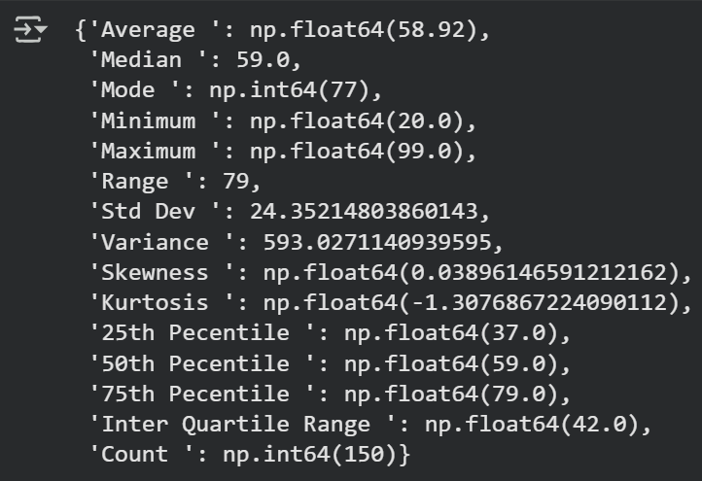
4. Create a script for systematic sampling by giving certain conditions and finding the desc stat for the dependent variable from the sample [Apply the descriptive function which you created].
def systematic_sampling(data, step, start=0):
"""
Systematic sampling function
Condition: Select every kth record starting from specified position
"""
indices = np.arange(start, len(data), step)
return data.iloc[indices]

# Apply systematic sampling with conditions
step = 15 # Condition 1: Select every 15th record
start_pos = 3 # Condition 2: Start from the 4th record (index 3)

systematic_sample = systematic_sampling(ds, step, start_pos)

print("SYSTEMATIC SAMPLING WITH CONDITIONS")
print(f"Condition 1: Select every {step}th record")
print(f"Condition 2: Start from position {start_pos + 1} (index {start_pos})")
print(f"Original dataset size: {len(ds)}")
print(f"Systematic sample size: {len(systematic_sample)}")

# Apply descriptive function to dependent variable
dependent_variable = 'Purchase Amount (USD)'
systematic_stats = Desc_stat(systematic_sample, dependent_variable)

print(f"DESCRIPTIVE STATISTICS FOR DEPENDENT VARIABLE: {dependent_variable}")
for key, value in systematic_stats.items():
print(f"{key}: {value:.2f}")
Output:
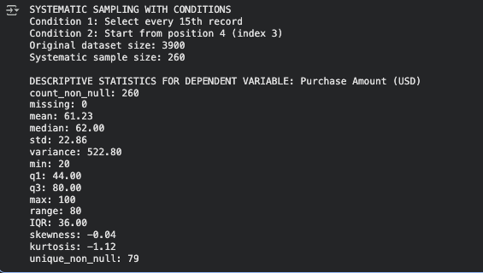

5. Create a detailed descriptive statistic report about the dependent variable of the chosen dataset.
import pandas as pd
import numpy as np
import matplotlib.pyplot as plt
from scipy import stats

# Choose dependent variable (edit if yours is different)
dep_var = "Purchase Amount (USD)"

# Choose dependent variable (edit if yours is different)
dep_var = "Purchase Amount (USD)"

desc = df[dep_var].describe()
extra = {
"variance": df[dep_var].var(ddof=1),
"skewness": df[dep_var].skew(),
"kurtosis": df[dep_var].kurt()
}
print("Descriptive Statistics for", dep_var)
print(desc)
print(extra)

Output: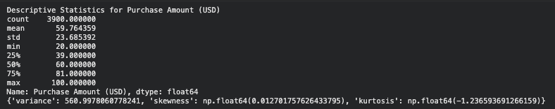
6: visualize the dependent variable by the graph/chart of the following using python program:
#A: Scatter Plot

# load the data
df = pd.read_csv('/content/shopping_behavior_100.csv') #data size = 30
# Define the dependent variable
dep_var = "Purchase Amount (USD)"
#Scatter plot:
plt.figure()
plt.scatter(df.index, df[dep_var])
plt.title(f"Scatter Plot of {dep_var}")
plt.xlabel("Index")
plt.ylabel(dep_var)
plt.tight_layout()
plt.show()
Output: 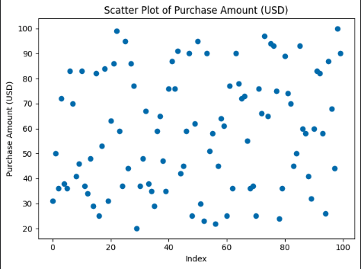
#B. Box Plot

# load the data
df = pd.read_csv('/content/shopping_behavior_100.csv') #data size = 1000

#Box plot
plt.figure()
plt.boxplot(df[dep_var].dropna(), vert=False)
plt.title(f"Box Plot of {dep_var}")
plt.xlabel(dep_var)
plt.tight_layout()
plt.show()

Output: 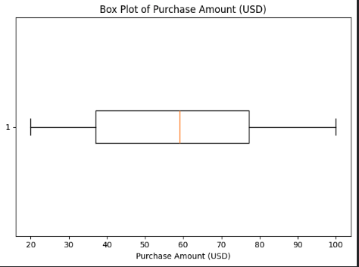

#C. Histogram

# load the data
df = pd.read_csv('/content/shopping_behavior_100.csv') #data size = 1000
#Histogram:
plt.figure()
plt.hist(df[dep_var].dropna(), bins=10, edgecolor='black')
plt.title(f"Histogram of {dep_var}")
plt.xlabel(dep_var)
plt.ylabel("Frequency")
plt.tight_layout()
plt.show()
Output: 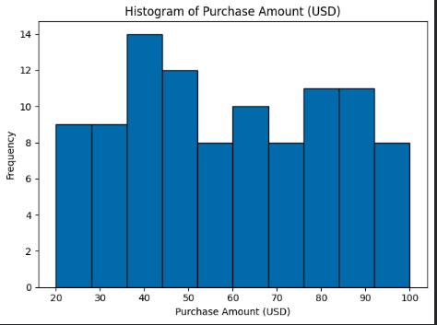
#D. Heat Map:
num = df.select_dtypes(include=[np.number])
corr = num.corr(numeric_only=True)

plt.figure()
im = plt.imshow(corr, aspect='auto')
plt.title("Correlation Heat Map (Numeric Features)")
plt.xticks(range(len(corr.columns)), corr.columns, rotation=45, ha='right')
plt.yticks(range(len(corr.index)), corr.index)
plt.colorbar(im)
plt.tight_layout()
plt.show()

Output: 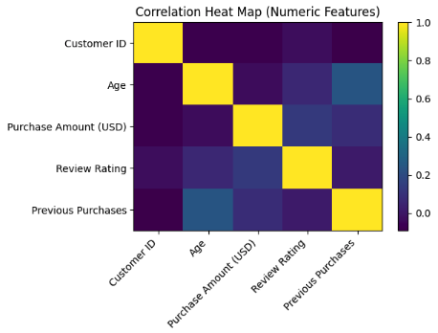

7. Hypothesis Test Conclusion:
The hypothesis tests were conducted to examine the relationship between the independent and dependent variables in the dataset.
The Pearson and Spearman correlation tests were used to measure the relationship between Age and Purchase Amount (USD).
Both tests produced correlation coefficients of –0.01 with p-values above 0.05 (p = 0.515 and p = 0.514), indicating no significant relationship between age and purchase amount. This means that changes in customer age do not meaningfully affect how much they spend.
The Chi-Square test was used to test the association between Gender and Purchase Amount.
The test returned a Chi-square value of 0.05 and a p-value of 0.819, which is greater than 0.05, showing no significant association between gender and spending behavior.
Overall, the results suggest that neither Age nor Gender have a significant influence on the Purchase Amount in this dataset.
Code:
import pandas as pd
from scipy.stats import pearsonr, spearmanr, chi2_contingency
import numpy as np

# load the data
df = pd.read_csv('shopping_behavior_updated1.csv')

# - NUMERICAL TESTS:
# Age (independent) vs Purchase Amount (dependent)
x = df['Age']
y = df['Purchase Amount (USD)']

# Pearson test (linear relationship)
pearson_r, pearson_p = pearsonr(x, y)

# Spearman test (rank/monotonic relationship)
spearman_r, spearman_p = spearmanr(x, y)

print("Numerical Correlation Tests: ")
print(f"Pearson Correlation: {pearson_r:.2f}, p-value: {pearson_p:.3f}")
print(f"Spearman Correlation: {spearman_r:.2f}, p-value: {spearman_p:.3f}")

if pearson_p < 0.05:
print("Pearson: There IS a significant relationship between Age and Purchase Amount.")
else:
print("Pearson: There is NO significant relationship between Age and Purchase Amount.")

if spearman_p < 0.05:
print("Spearman: There IS a significant relationship between Age and Purchase Amount.")
else:
print("Spearman: There is NO significant relationship between Age and Purchase Amount.")

# - CATEGORICAL TEST:
# Gender (independent) vs Purchase Amount level (High/Low)
df['_PurchaseLevel'] = np.where(df['Purchase Amount (USD)'] >= df['Purchase Amount (USD)'].median(), 'High', 'Low')

# Create contingency table
table = pd.crosstab(df['Gender'], df['_PurchaseLevel'])

# Chi-square test
chi2, p_chi, dof, exp = chi2_contingency(table)

print()

print("Categorical Test (Chi-Square): ")
print(f"Chi-square value: {chi2:.2f} | p-value: {p_chi:.3f}")

if p_chi < 0.05:
print("Chi-Square: There IS a significant relationship between Gender and Purchase Amount.")
else:
print("Chi-Square: There is NO significant relationship between Gender and Purchase Amount.")
Output: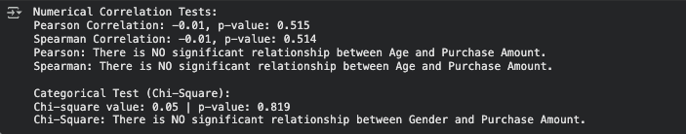

8. One-Sample T-Test using population mean from full dataset
# Q8: One-Sample T-Test using population mean from full dataset

import pandas as pd
import numpy as np
from scipy import stats

df = pd.read_csv("shopping_behavior_updatedNEW.csv")

def systematic_sampling(data, step, start=0):
indices = np.arange(start, len(data), step)
return data.iloc[indices]

step = 15
start_pos = 3
systematic_sample = systematic_sampling(df, step, start_pos)

# Select dependent variable
dep_var = "Purchase Amount (USD)"

# Population mean from the full dataset
population_mean = df[dep_var].mean()

# Sample values from the systematic sample
sample_values = systematic_sample[dep_var].dropna()

# Perform one-sample t-test
t_stat, p_value = stats.ttest_1samp(sample_values, population_mean)

print("One-Sample T-Test Results")
print("--------------------------")
print(f"Population Mean: {population_mean:.2f}")
print(f"Sample Mean: {sample_values.mean():.2f}")
print(f"T-statistic: {t_stat:.4f}")
print(f"P-value: {p_value:.4f}")

# Interpretation
alpha = 0.05
if p_value < alpha:
print("Conclusion: The sample mean is significantly different from the population mean.")
print("The sample may not represent the normal population.")
else:
print("Conclusion: There is no significant difference between the sample and population mean.")
print("The sample represents the normal population.")
Output: 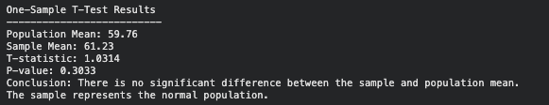

Task 3
9. Build, Train, Develop and Evaluate using Simple Regression for chosen dataset.

# Define independent (X) and dependent (Y) variables
X = ds.iloc[:,[15]].values # independent variable (Previous Purchases)
y = ds.iloc[:,5].values # dependent variable (Purchase Amount)

# Split data into train and test sets (80% / 20%)
from sklearn.model_selection import train_test_split
X_train, X_test, y_train, y_test = train_test_split(X, y, test_size=0.2)
print(X_train)
print(X_test)
print(y_train)
print(y_test)

# Training the Simple Linear Regression model on the Training set
from sklearn.linear_model import LinearRegression
regressor = LinearRegression()
regressor.fit(X_train, y_train)

# Predicting the Test results
y_pred = regressor.predict(X_test)
print(X_test)
print(y_pred)

regressor.predict([[34]])
Output:

# Visualize the Training set results
plt.scatter(X_train, y_train, color = 'red')
plt.plot(X_train, regressor.predict(X_train), color = 'blue')
plt.title('Purchase Amount vs Previous Purchases (Training set)')
plt.xlabel('Previous Purchases')
plt.ylabel('Purchase Amount (USD)')
plt.show()
Output:
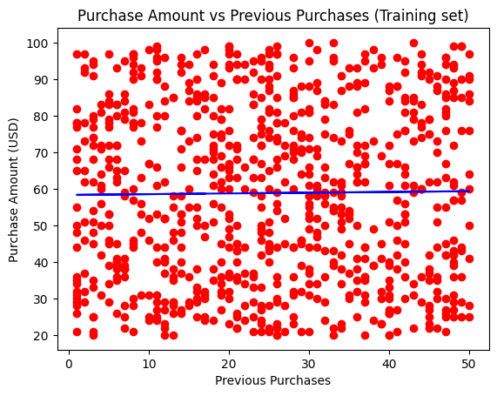

# Visualizing the Test set results
plt.scatter(X_test, y_test, color = 'pink')
plt.plot(X_train, regressor.predict(X_train), color = 'purple')
plt.title('Purchase Amount vs Previous Purchases (Test set)')
plt.xlabel('Previous Purchases')
plt.ylabel('Purchase Amount (USD)')
plt.show()

Output:
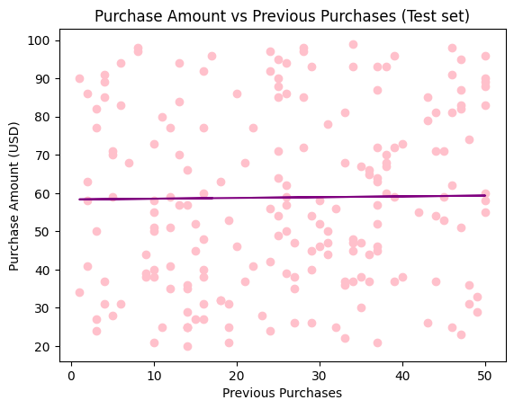

# get the intercept and the coefficent
b0 = regressor.intercept_
b1 = regressor.coef_
print('The intercept is:', b0)
print('The coefficent is:', b1[0])
Output:
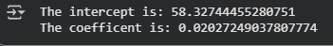

from sklearn.metrics import r2_score

# model evaluation
r2_score(y_test, y_pred)
Output:

12. Evaluate Models using Confusion Matrix and Accuracy

13. Predict using Best-Fit Model (Random Forest)
from sklearn.ensemble import RandomForestClassifier

best_model = RandomForestClassifier()
best_model.fit(X_train, y_train)

#Predict on test data
y_pred = best_model.predict(X_test)

#Display sample predictions
predictions = pd.DataFrame({'Actual': y_test, 'Predicted': y_pred})
print("\nSample Predictions:")
print(predictions.head(10))

Output: 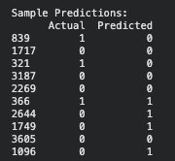

14. Hierarchical (Horizontal) Clustering:
import pandas as pd
import matplotlib.pyplot as plt
import scipy.cluster.hierarchy as sch
from sklearn.cluster import AgglomerativeClustering
from sklearn.preprocessing import StandardScaler

# Load dataset
df = pd.read_csv("shopping_behavior_100.csv")

# Use numeric fields
X_num = df[["Age", "Purchase Amount (USD)"]].dropna()

# Scale data
scaler = StandardScaler()
X = scaler.fit_transform(X_num)

# ---- Create clusters (choose k=4 as example) ----
agg = AgglomerativeClustering(n_clusters=4, linkage="ward")
labels = agg.fit_predict(X)

# ---- Scatter plot for Hierarchical clusters ----
plt.scatter(X[:, 0], X[:, 1], c=labels)
plt.title("Hierarchical (Agglomerative) Clusters")
plt.xlabel("Age (scaled)")
plt.ylabel("Purchase Amount (scaled)")
plt.show()

Output: 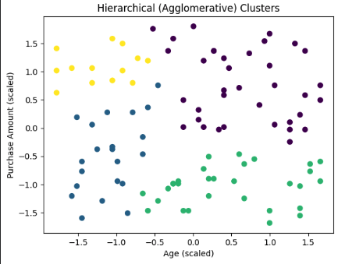

Hierarchical (Agglomerative) Clustering:
import pandas as pd # Import pandas
from scipy.cluster.hierarchy import dendrogram, linkage
import matplotlib.pyplot as plt

# 1. Load dataset
df = pd.read_csv("shopping_behavior_100.csv")

#Select numeric fields
cluster_data = df[['Age', 'Purchase Amount (USD)']].dropna()

linked = linkage(cluster_data, method = 'ward')
plt.figure(figsize=(8, 4))
dendrogram(linked, orientation = 'top', distance_sort = 'descending', show_leaf_counts = True)
plt.title("Hierarchical Clustering Dendrogram")
plt.xlabel("Samples")
plt.ylabel("Distance")
plt.show()

Output: 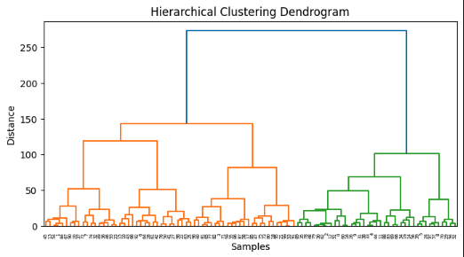
Perform K-means for fields from the dataset:
k = 4
kmeans = KMeans(n_clusters=k, init="k-means++", random_state=42, n_init=10, max_iter=300)
labels = kmeans.fit_predict(X)

clustered = data.copy()
clustered["Cluster"] = labels

plt.figure()
for c in sorted(clustered["Cluster"].unique()):
plt.scatter(
clustered.loc[clustered["Cluster"] == c, "Age"],
clustered.loc[clustered["Cluster"] == c, "Purchase Amount (USD)"],
s=60,
label=f"Cluster {c+1}"
)

centroids_unscaled = pd.DataFrame(
scaler.inverse_transform(kmeans.cluster_centers_),
columns=feature_cols
)

plt.scatter(
centroids_unscaled[feature_cols[0]],
centroids_unscaled[feature_cols[1]],
s=600, c="yellow", edgecolors="black", linewidths=1.2,
label="Centroids", zorder=5
)

plt.title("K-Means Clustering", fontsize=18)
plt.xlabel("X") # to mimic the example's axis labels
plt.ylabel("Y")
plt.legend(framealpha=0.9, title=None)
plt.tight_layout()
plt.show()

print("Cluster centroids (original units):")
print(centroids_unscaled)

Output: 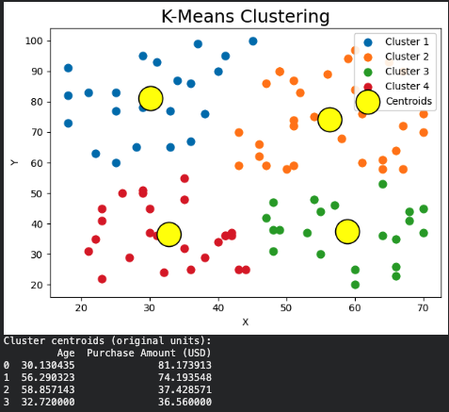

Using the Elbow method to find the optimal number of clusters:
import pandas as pd
import matplotlib.pyplot as plt
from sklearn.preprocessing import StandardScaler
from sklearn.cluster import KMeans

df = pd.read_csv("shopping_behavior_100.csv")

feature_cols = ["Age", "Purchase Amount (USD)"]
data = df[feature_cols].dropna().reset_index(drop=True)

# 3) Scale features for K-Means
scaler = StandardScaler()
X = scaler.fit_transform(data)

wcss = []
for k in range(1, 11):
km = KMeans(n_clusters=k, init="k-means++", random_state=42, n_init=10, max_iter=300)
km.fit(X)
wcss.append(km.inertia_)

plt.figure()
plt.plot(range(1, 11), wcss)
plt.title("Elbow Method (Age + Purchase Amount)")
plt.xlabel("Number of clusters (k)")
plt.ylabel("WCSS")
plt.show()

Output: 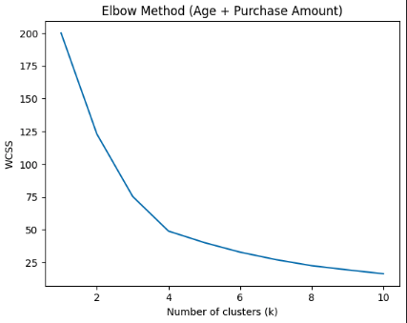

15. Explain the strategy for improving the system after viewing the cluster diagram:

After analyzing the cluster diagram, it becomes clear that customers can be grouped based on their age and purchase amount into four main segments. Each cluster represents customers with similar buying patterns — for example, younger customers with high spending or older customers with lower purchase amounts.
To improve the system, the next step is to personalize marketing and product recommendations for each group. For instance, promotions can target high-spending clusters to increase loyalty, while lower-spending groups can be offered discounts or bundles to encourage more purchases. Additionally, collecting more data such as income, gender, or visit frequency could help make the clustering more accurate.
Finally, by combining clustering insights with classification models (like Random Forest or KNN), the system can predict future customer behavior and automatically group new customers into the right cluster, improving decision-making and overall business performance.
Task 4

